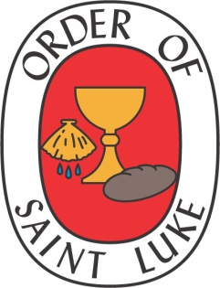
The Order of Saint Luke
Book of Reports
for the Spring Council Meeting
May 9-10, 2023

REPORT PAGE

Report of the Abbot – Sr. Elizabeth Moore | 2-3
Report of the Prior General – Br. George R. Crisp [Action items] | 4-5
Report of the Chancellor General – Sr. Jeanette Block  Report will be given at the meeting – Reimbursement Policy (pp. 6-8) – Financial  Holidngs and Investments [Action items] | 6-8
Report of the Provincial General – Sr. Heather Josselyn-Cranson | 9-12
Report of the Director of Periodicals / Doxology – Br. Jonathan Hehn | 13
Report of the Font Editor / Companion for Life-Vowed Members – Sr. Cynthia Astle | 14
Report of the Chaplain General – Sr. Celia Halfacre | 14
Report of the Director of Aquisitions and Author Relations – Br. Daniel Benedict | 15
Report of the Webscribe – Br. Scot Bontrager | 16
Report of the Daily Office Revision Team – Br. Dwight Vogel | 17
Report of the Pastoral Care Officer – Sr. Dianne Covault | 17
Report of the Companion for Seekers, Inquirers and Discerners – Br. Jim DuFriend | 18
Report of the Historian / Our Story Project – Br. Mark Stamm | 19-21
Novitiate Team Report – Br. Daniel Benedict | 22-26
Minutes of the October 5, 2022 General Chapter Meeting | 27-28

The Book of Reports for the Council of the General Chapter
The Order of Saint Luke

Report of the Abbot

Here in southern California we have experienced a cold and exceptionally rainy spring. But now we are experiencing the beautiful payoff. From my office window I can see a riot of colorful flowers, green bushes, and blue sky. New life is springing up everywhere. It can be difficult on dull, grey days to remember that Spring is coming. Days when the world and national news is depressing. Days when another friend has contracted Covid. But we hold onto hope. The church choir sings an anthem that lifts our hearts. Young people that we love are confirmed in the church. We see baby hummingbirds in their nest. And Easter becomes alive again in our soul.
As the days carry us closer to Pentecost, may we let ourselves become the Wind and Flame that will carry God’s love throughout the world.

As I look back at this year, I recognize that our retreat last October brought hope to my soul. It was wonderful to watch as we gathered in Scottsdale. The familiar faces of our elders were there, bringing their wisdom and experience. And an exciting number of young members were there, bringing their enthusiasm and creativity. And the musicians. Oh, the musicians! I remember my fear as Br. Bill Beasley, of sainted memory, grew unable to be our organist. What would we ever do without him? I rejoice that I now know the answer to that question. We will welcome the amazing talents of the brothers and sisters among us who each, in their own way, lift our spirits to God when we worship together.

In the months since last October’s retreat. Your officers have been busy with the administrative tasks of the Order. With help from Br. Taylor Burton-Edwards and Br. French Ball, we have developed suggested changes to our Bylaws that will be presented at our Council meeting. Br. Daniel Benedict has been working on streamlining our process for inquirers, both to make it more responsive and more effective. We continue to look at how our existing chapters can play a crucial role in bringing people into the Order. Br. Jonathan Hehn contributes precious time and talent to the publication of Doxology which provides us an audience beyond our vowed members. Br. George has worked to organize our October Retreat and to administer our Hickman Award Program – both very big tasks that he does with skill and love.

These, and many others, are the lifeblood that keeps the Order functioning. I give them my thanks. I hope that you all will be able to come to Pittsburgh in October. We live as a dispersed Order, but it is good for the soul to talk and hug and laugh together occasionally.

+ Blessings,
Sr. Abbot Elizabeth
October 2022

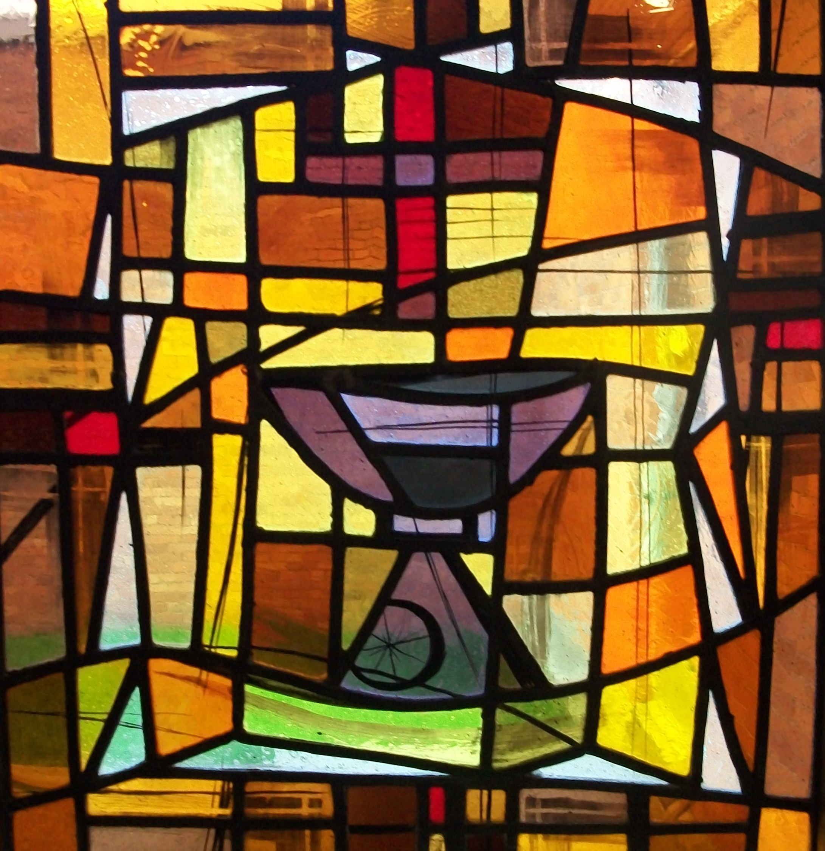

Report of the Prior General

Of the 19 seminaries that present the Order’s Hoyt L. Hickman Award, 17 schools are presenting the award between April 14 and May 20. Each recipient is a graduating student who has shown exceptional ability in liturgical scholarship and/or exceptional ability in leading worship. A new consideration this year was presenting the award to a student in a hybrid program. Ceramic chalice and paten sets, crafted by E. Preston Rice, are presented to the recipients. (In addition, one award was a ceramic bowl offered to a Christian Scientist student who has no use for a communion set.) With your permission, I would like us to invite Hickman Award recipients to this year’s retreat.

Our annual Retreat is being held October 16-19. We will return here to St. Paul of the Cross.
The guest speaker will be Debie Thomas, a columnist for the weekly webzine Journey with Jesus and a contributing editor for The Christian Century. Her topic for our Retreat is Sacred Connection: Engaging Spiritual Practices in a Turbulent World. (See next page for details.)
Her first book, Into the Mess and Other Jesus Stories, was published last year by Cascade Books. Debie, a lay woman, serves as the Minister of Lifelong Formation at St. Mark’s Episcopal Church in Palo Alto, California.

We will meet at St. Paul again next year for both our Spring Council meeting and our 2024 Retreat. The specific dates will be announced at the meeting (once they are reserved). With Br. Daniel Benedict’s help we have engaged Dr. Gordon Lathrop to be our presenter. In late March, Dr. Lathrop, Br. Daniel and I had a Zoom meeting, and Dr. Lathrop was enthusiastic about being our retreat presenter.

[Action Item] Two items for discussion: (1) Developing a policy that spells out our practice of covering retreat speaker’s travel expenses in addition to an honorarium; and (2) Developing a policy on reduced rates for part-time Council or Retreat attendees

Br. George R. Crisp, OSL
April 21, 2023
Introducing Debie Thomas
Retreat Speaker for October 16-19, 2023
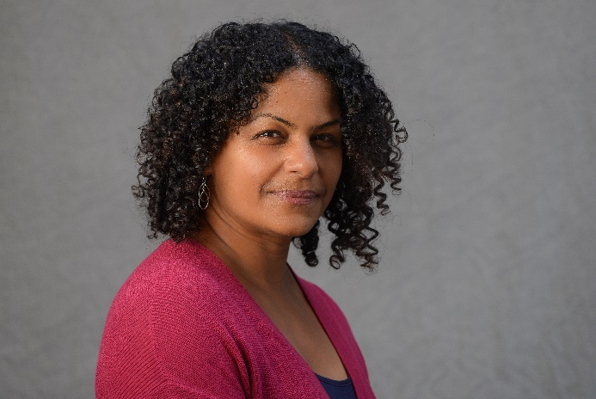
Debie Thomas is a columnist and contributing editor for The Christian Century. From 2014 to 2022, she served as a staff writer for Journey with Jesus: A Weekly Webzine for the Global Church.

Her first book, Into the Mess and Other Jesus Stories, was published this spring and in now available. Her published work includes spiritual memoir, book reviews, and reflections on the Revised Common Lectionary. She also serves as the Minister or Lifelong Formation at St. Mark’s Episcopal Church in Palo Alto, California.

Her Topic for our Retreat:
Sacred Connection: Engaging Spiritual Practices
in a Turbulent World

How can Christian leaders make a case for robust spiritual practice
in a culture that is harried, distracted, wounded and wary?

Session 1: Replenishing the Well
We can’t share from wells that are dry. We can’t lead others into
places we haven’t discovered for ourselves.

Session 2: Giving Away What We Seek
How might we engage 21st century parishioners in the practices of
our tradition?

Session 3: Lost in Translation
What is missing in contemporary spiritual practice?

Report of Chancellor General

Sr. Jeanette’s formal report will be given at the Council meeting. To reach Sr. Jeanette, please note her address: 1194 Fries Mill Road, Franklinville, NJ 08322. As always if you have any questions or concerns, please email me at oslchancellor@gmailcom or call at 609-364-9187.

On the following page is the Reimbursement Policy that was passed at the General Chapter meeting last October.

Council of the General Chapter Reimbursement Policy
(Adopted at the General Council meeting, October 5, 2020)

The Council of the General Chapter of The Order of Saint Luke meets twice each year - in May and at the general retreat in October. All members of the Council pay their own expenses to attend the October meeting. The General Chapter has attempted, however, to fund the May meeting.

In May 2008, the total cost of the meeting exceeded $14,000. This was due to a variety of factors - increased attendance, higher gasoline and airline prices, and a major NASCAR event in Charlotte all contributed to the high cost. Clearly, an organization with a $40,000 annual budget cannot commit 35% of that budget to one business meeting. A look at our previous policies (drawn here mostly from memory and custom, rather than actual documents
(if, in fact, documents ever existed) and a move toward a new policy is called for.

The following elements were a part of our Council Expense Policy through this past May's meeting:
- The elected and appointed general officers, including Canons, of The Order will have their expenses covered by the General Chapter. The five elected general officers will have their travel, room, and board costs for the spring meeting reimbursed as a "first claim" on the Council meeting budget. [See phantom footnote below]
- Up to seven Provincial Companions will have their expenses covered by the General Chapter.
- Representatives of Chapters should have their expenses covered by their respective chapters. However, when the chapter is unwilling or unable to pay, the General Chapter will cover those expenses.
- Representatives of Associations should have their expenses covered by their respective chapters. However, when the chapter is unwilling or unable to pay, the General Chapter will cover those expenses.
- Council members living within 500 miles of a meeting location should probably drive, unless they can demonstrate that flying is less expensive.
- Mileage will be reimbursed at the "federal rate.”

There have been many problems with this policy, but the chief one is that we simply cannot afford it any longer. A new policy that encourages broader support from chapters and associations, and that assures General Officers of expense coverage is needed. In the spirit of "getting something before us to discuss," I suggest the following as our new Council Expense Policy:

- The General Chapter of The Order of Saint Luke will offer financial support to members of the Council of the General Chapter in attendance at the annual May meeting, but no such financial support is offered for the annual October meeting.
- Chapters and Associations of The Order are expected to fund the attendance of their representatives at the meetings of the Council of the General Chapter.
- The five elected general officers will have their travel, room, and board costs for the spring meeting reimbursed as a "first claim" on the Council meeting budget.
- The general officers appointed by the Abbot, including Canons, may have their travel, room, and board costs for the spring meeting reimbursed as a "second claim" on the Council meeting budget.
- Up to three Provincial Companions may have their travel, room, and board costs for the spring meeting reimbursed as a "third claim" on the Council meeting budget.
- Chapter and Association representatives may have their travel, room, and board costs for the spring meeting reimbursed as a "fourth claim" on the Council meeting budget.
- The General Chapter funds semi-private accommodations; the extra cost for a private room, or to bring along another person, are not reimbursed.
- Mileage will be reimbursed at the "federal rate."
- Council members living within 500 miles of a meeting will have their airfare reimbursement limited to the amount they would have received if they had driven.
- Council members are expected to use great care and due diligence in their planning, taking advantage of all available discount programs, various forms of public transportation, and making early reservations.
- Carpooling is highly encouraged.

In addition, the Chancellor General will explore the various "hub" airports around the country, and lodging options near each, with the intention of bringing a recommendation to the May 2009 Council meeting of preferred locations for Council meetings. Not only do we need to be aware of the cost to Council members, but also the cost of the meeting's carbon footprint.

Report of the Provincial General

Sr. Heather Josselyn-Cranson, OSL
OSL Chapter Reports – May 2023

Chapter | Prior | Mem-bers | Activity | Prayer Requests | News
Mid-Atlantic Chapter | Br. Brett Isernhagen (subp. Sr. Hilde Gates) | 6 | Monday Terce with psalter chanting, checking-in, and discussion | Comfort, joy, and peace for Sr. MaryO and all whose lives touch hers | Becoming an official chapter!
Trinity Chapter  (N. Texas) | Br. Scot Bontrager (subp. Sr. Magdalene Ruth) |  | Monthly meetings for Eucharist and fellowship
Charles Mosebrook Chapter | Sr. Lynn Basan | 14 | Regular gatherings on-line; Christmas meeting in Bagulo. | Br. Melvin Sulit’s move to Canada; military siblings up for reassignment; prayers for the well-being of Brs. Allen Munda and Norlie Vilog.
New Jersey Chapter | Sr. Debbie Neill | 14 | Second Monday worship followed by book discussion on Zoom | Health and well-being of members facing life-changing situations
Cal-Pac Chapter | Br. George Crisp, Prior pro tem | Same mem-ber-ship | In-person Chapter meeting February 7; weekly Thursday PM prayer on Zoom at 4 PM | For Br. George Martzen as he copes with pulmonary fibrosis

Dayspring Chapter | Sr. Laura King | 10/32 | Tuesday PM prayer and Thursday AM prayer each week; also a special service for Jim Radloff moving from seeker to Inquirer. | Br. Daniel and Sr. MaryO; Sr. Mary Balinda, Br. Robert and Sr. Rosemary Davis; Sr. Candace and Ron, Br. Bert, Sr. Laura, Br. Haywood and Sr. Martha, Sr. Jeannette and Ron, Br. Logan, Br. Mark and Sr. Margie, Br. Bob, Sr. Becky, Br. Jack, Br. French
Winged Ox Association | Br. Andrew Owen | 3 | Br. Taylor became a member of the Order! | Prayers for Br. David stepping down as prior and becoming active in Oregon. Prayers for Br. Andrew seeking to grow the Order in its physical location.
Singapore Chapter | Br. Anthony Goh | Same as previously | Gathering on October 18, led by Br. Benjamin on communion liturgies for children
St. Francis Chapter | Sr. Alice Kay Lovelace | 13 | May Zoom meeting and June in-person at West Ohio Annual Conference | Prayer for the St, Francis Chapter as its pre-COVID tradition of leading AM prayer at AC was first cancelled for 3 years and now will be held at a different location.
Upper  New York Chapter | Br. Brett Johnson | 11 | Zoom meeting on Feast of St. Luke and Annual Conference in June | Prayers for Charles and Kimberly Smith (health), Br. Brett’s upcoming ordination, and chapter leadership and discernment.
Illinois Great Rivers Chapter | Br. Mick Laflin | 15 | Monthly hybrid times of worship, study, and sacrament. Planning for Eucharistic leadership at Annual Conference. |  | Br. Mick’s upcoming retirement
Hoyt Hickman Memorial Chapter | Sr. Kimberly Greway | 40 on mailing list | Twice monthly Zoom afternoon prayer | Health concerns, retirements, and new appointments
Koinonia Chapter | Br. Aiden | 12 | Monday AM prayer each week, quarterly chapter meetings.

Philippines Chapter | Br. Ador Tolentino | 8 sub-chapters | National Convocation October 17-19; November 11-12 “Tree Planting for a Cause” (to benefit a church rebuilding); Nov 30 discussion of the Rule of Life and Service; sub-chapter activity since then |  | This chapter wins the award for best (and most) photos submitted with a report!
Perkins STH Chapter | Sr. Heather Gottas, with Br. Mark Stamm | 7+ | Weekly morning prayer on Zoom on Tuesdays, with formation happening once per month. | Transition in UMC higher education that affects Perkins | Dianne McCleary and Deborah Wade were affirmed as initial members on April 17 and hope to take vows at the October retreat

Report of the Director of Periodicals / Doxology

Overview – Since my Fall 2022 report, three issues of Doxology have been published: Volume 33.2 (Pentecost 2022), Volume 33.3 (Ordinary Time 2022), and Volume 33.4 (Advent-Christmas 2022). As mentioned before, I have reworked the entire deadline structure for 2023 to help the 2023 and future issues come out on time. Volume 34.1 (Lent-Easter 2023) is currently in production, and I have a decent number of submissions lined up for the rest of this year.

File organization and indexing – The digital archive for Sacramental Life still needs to be completed. I would be appreciative if the Council could find someone who can take on that task.

Editorial Practices – The stream of unsolicited submissions is now better, but not enough to reliably fill 4 issues per year. At this point, I think there are two strong possibilities. First, we should still consider whether to move to a thrice yearly production schedule. Second, though, if a part-time person is hired to help bolster the work of OSL Publications, that person could help market Doxology in a more consistent way that would increase submissions and subscriptions.

The work of the production team and board of editorial advisors remains strong, and I’ll especially point out the outstanding work of Br. Benjamin Fong, who has served as a copy editor. I could still use one additional copy editor, but the team seems to work fairly well as is. Karen Tunnell is out as our Visual Art Editor, and I have not yet been successful in finding a replacement.

Distribution – I am renewing my call from my Spring and Fall 2022 reports to consider hiring a part-time business manager for OSL publications to handle the periodical subscriptions, customer service issues for both books and periodicals, and to engage in marketing efforts for both sides of our publications ministry. I look forward to being part of those discussions virtually this coming week.

Finally, on a personal note, I regret not being able to be with you this past year at Council meetings and retreats. I truly miss being with you, but because of my academic schedule and the complications in my personal life this year, I have been unable to be there. Looking forward to rejoining you all in community soon.

Submitted by Jonathan Hehn
May 3, 2023
Report of the Font Editor

We successfully transferred OSL's MailChimp account to a pay-as-go plan with credits for 10,000 emails. This is an annual subscription, so we can send this many emails prior to January 9, 2024, so let's get busy with more communications!

Report of the Companion for Life Members

Br. Frank Richard Coats sent an inspirational message to our Life-vowed members with the Companion's approval.

That's it. Sorry I won't be at the spring meeting, but my husband John and I are planning to attend Retreat in October.

Blessings,
Sr. Magdalene Ruth
April 25, 2023

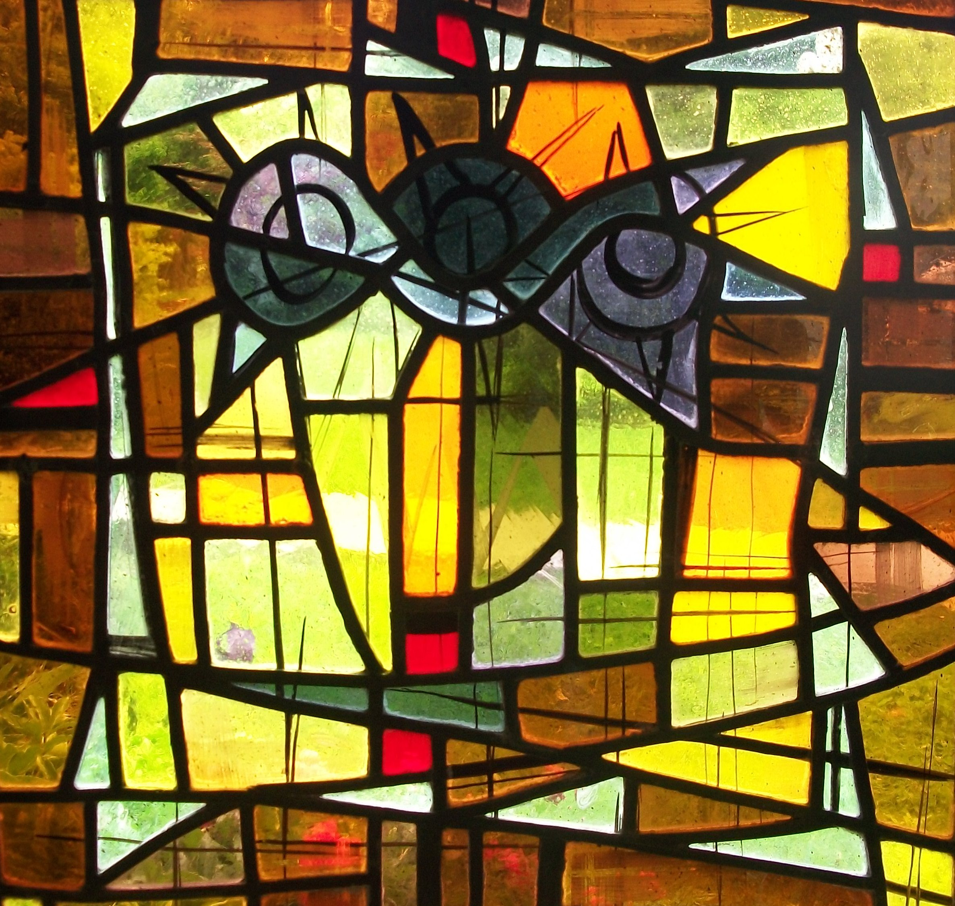
Report of the Chaplain General

It’s spring in South Texas and the wind rages here, but my soul is calm(ish). I’m adjusting to South Texas living and adjusting into my new role as your chaplain general. I offer my gratitude to all of you that when I’ve reached out to you with a request you’ve always answered the call to serve with joy. Thank you for that.

In reading previous reports from chaplains general, I noticed Sr. Alice mentioned that Br. Lewis Worthington was in possession of some of our holy hardware here in Texas. I’ve reached to Br. Lewis and we will make plans to get that holy hardware to me, the next time I’m near the Austin area. In our spring meeting I hope to make some plans about how to handle the holy hardware in the future. As I live in South Texas, and it’s not inexpensive to ship it around, we’ll have to come to a good plan for how to make sure the hardware is stored where it needs to be. Perhaps we can find a way to repackage it for easier shipping and inventory.

I am available to answer questions you may have.

Yours in Christ,
Sr. Celia Halfacre
April 22, 2023
Report of Director of Acquisitions and
Author Relations for OSL Publications


As of March, and following a conversation with Abbot Elizabeth, I have requested termination of my role as Director of Acquisitions and Author Relations. With Sr. MaryO in hospice and all that goes with that, I simply don’t have the energy and time to devote to this office.

However, I think it necessary for good order and transition to report the following:

- Two publications are in limbo with no movement: (See Book of Reports – fall 2022 – for details.) on a festschrift, Loving Confidence, and Living the Rule.

- There is still an outstanding project to digitize and update an edition of the John Wesley’s Prayer Book.

- Royalty checks and letters for 2022 have been sent out to authors of our current titles.

- Files in my custody, namely 1) copies of our royalty agreements/letters of understanding, and 2) our ISBM numbers and related papers will be given to our Chancellor General at the Spring Council Meeting of the Order (May 2023). Our Chancellor General also keeps copies of these files.

Br. Daniel Benedict
April 27, 2023

Report of Webscribe

In the past year there have been only routine updates to the website. The last major re-design was in 2020/2021. We continue to list upcoming events and provide registration for the events on the website. The Facebook group is still the primary means of online communication for the majority of our members.

The link for “reaffirmation” has been removed from the front page since members of “The Order of Saint Luke the Physician” were accidentally using our form. The reaffirmation form still exists under a menu option, just not on the front page.

The Web-Amplified Daily Office has undergone a complete re-write, the first major upgrade in a decade. I will do a formal presentation of the work done at the May Council meeting.

Br. Jonathan Hehn continues to be in charge of the publications website and store.

Hosting for both websites costs $24.95 per month, I personally fund this as part of my contribution to the Order. There are a few other miscellaneous expenses each year related to domain names, software license, and the like. WADO database hosting costs about $0.04/mo.; Google has not billed us for this cost.

We continue to need pictures of members and events for the website. As photos are shared to the Facebook group I update the website.

We should probably start thinking about a “refresh” in another year or so.

Br. Scot Bontrager
April 11, 2023

Report of the Daily Office Revision Team (DORT)

Work this year has focused on two projects:

- Completing the work of integrating material from A Lukan Daily Lectionary (based on Revised Common Daily Lectionary) with recommended psalms for morning and evening prayer growing out of the lectionary in A Lukan Psalter, the psalms in the last section of The Daily Lectionary (Br. Mark Stamm, ed.), and psalms in other ecumenical sources. Draft for year C is now completed. A, B and C may now be used for WADO

- Developing a customary for offices and services of the Order to provide a tool for use by the chaplain general and other planners of worship experiences was completed and reviewed in October.

- Our primary focus now will be on developing the Web Amplifed Daily Office (WADO).
Canon Dwight Vogel, OSL
April 27, 2023

Report of the Pastoral Care Officer

I remain excited for the possibilities of this position. In the past months, I have received one email requesting care and have reached out to several individuals via Facebook. As Facebook is not my preferred means of communication, I am open to seeking other ways to be in care for persons in the Order.

My current ideas include (1) regular zoom “office hours” where I remain online to speak with any who come into the zoom chat (2) in concert with Sr. Kimberly, a quarterly online zoom healing service of some sort. At retreat, I would like to have a set apart time for the office of reconciliation with individuals and/or a time when I can be available to all who would like to meet with me individually.

I do believe strongly that my purpose is to be available and visible to members of the Order, but not to seek to insert myself into their lives if they have sufficient support from other areas.
I welcome insights and ideas.

Sr. Dianne Tobey Covault
April 27, 2023

Report of the Companion for

Seekers, Inquirers, and Discerners

The Order of Saint Luke website provides information to those wishing to know more about the Order. They are directed to me for further information. When I am contacted by them, I am able to direct them to the Facebook group for Seekers, Inquirers, and Discerners where they are able to access several documents which assist them with information about the Order. When they wish to move forward, they complete an application which gives basic information about themselves. Then comes the difficult part for me: assigning a companion to walk with them through their journey of Inquiry. This is especially difficult when there are so many in the process and needing Companions.

At the present time there are forty-six (46) Inquirers from twenty-three (23) States, one in the UK, one in South Africa, and one in Italy who are at various stages in the process of becoming acquainted with the Order. Some of the Inquirers have been able to connect with local chapters but most are not close to other members of the order but have been able to connect through virtual meetings. We continue to need members willing to be companions.

Br. Jim DuFriend
Companion to Seekers, Inquirers, and Discerners
April 12, 2023

Report of the Historian / Our Story Project (OSP)

In this report, I’ll report on some challenges and prospects. Then I shall make two specific requests, followed by a summary on some progress made with the project along with other requests.

First the Challenges:
- It has been a difficult year for us in the Stamm household, with the continued extended parenting and mentoring of our adult son, and the various (and ongoing) health challenges that Sister Margie and I have faced.
- It has been a year of transition in The United Methodist Church and its institutions of higher education. That dynamic particularly affects my work of chapel oversight.
- As to the Our Story Project and the historical work, gathering volunteers and other information has been difficult. Sometimes my queries have gone unanswered.
- As I have expressed before, some siblings seem to believe that the Our Story Project and other historical work is mine alone. The occasional help is much appreciated, but I could use some appointed help for a working group that could function somewhat along the lines that DORT has followed.
Next, the Prospects:
- I’m still energized by the work of this project, actually like doing it, and believe in its importance.
- SMU/Perkins has gifted me with a research leave for fall term 2023, which means that I have significant calendar flexibility from now through the end of December. This should make my requests (see below) easier to fulfill.

My Two Specific Requests:
- I would like access to all extant membership lists, including the card file of (I think) Thorwald Torgersen’s creation and/or maintaining. Commentary and rationale on this request:
- As I have said before, I’m hoping to develop a comprehensive list of all those who’ve been members of the Order, even for a short period of time.
- I accept the fact that such a list would likely end up being incomplete and would always be under construction, but it would help in the historical work that I would like to do. For example, it would help to take such questions as “Who was the first female member and when did she join?” out of the realm of speculation.
- I have some membership lists and also access to at least one membership list printed as part of The Versicle during the 1950s (James F. White shows up briefly at one point)
- In all of this, I think Thorwald’s card file is the Holy Grail. Given its historical significance, I understand reluctance to send it to me. So, wherever it is, I’ll come to you for a few days if we think that’s best. If a visit is discerned as the best way forward, let’s make that as easy (and as inexpensive) as possible, and let’s see if we can schedule that, at least tentatively, before I return to Dallas this week.
- I want to do a research visit to New Jersey, for the purpose of doing further interviews and research on the mother chapter and, in particular, for interviews relating to the life and ministry of Sister Karen McMartin. As far as I can determine, she was the first female General Office of the Order. Further rationale and commentary on this request:
- I had tried to set this in motion last spring (2022) but then Sister Karen died during the summer. But memories of her are still fresh, and I would like to see if we can gather stories about her, including from the last church where she served as a retiree.
- I would also like to gather stories regarding Sister Fran Ballinger.
- Again, I think a visit would be helpful to these ends, and such a visit could also give me the opportunity to visit the OSL archives in Madison, NJ. Could we put something on the calendar, at least tentatively, and again, perhaps before I return to Dallas this week?

- On both of these requests to schedule visits, remember that my fall schedule is relatively open, including the time in and around the fall retreat in Pittsburgh, scheduled for October 16-19.

Summary of Progress, Some Highlights:
- Sisters and Brothers who have helped recently, and may their tribe increase:
- Sisters Jennifer Kilpatrick and Carolyn Tanner have done excellent work compiling transcripts and are committed to doing more of them, and/or are in process of the same.
- Sister Cherlyn Gates has done some excellent work uncovering historical details on various persons of interest to the Order, Romey Marshall and others.
- Brother Daniel Benedict has assisted in sending me various items of interest.

- I have found someone to interview regarding John Fellers, OSL, who was largely influential in forming the well-developed liturgical sensibilities of St. Paul’s UMC located in the hospital and museum district of Houston.
- I have been able to interview a student of Grady Hardin’s. In my opinion, Grady’s witness was in large part missing from Robert Peiffer’s otherwise very helpful dissertation How Liturgies Evolve.
- And I had asked Brother Jonathan Hehn to allow me to an occasional “From the Historian” column in Doxology. A first step from my end should be preparing my October-December presentation for consideration in Doxology.

In continuation from the previous reports, here are some other ways that you may contribute to the Our Story Project, and I hope that you will consider doing so.

- Transcribe interviews.
- Submit your written accounts and other printed materials.
- Volunteer to be interviewed.
- Volunteer to conduct interviews, and especially in and around the sectors of the Order that you have known and experienced.
- Encouraging siblings (including yourself, dear reader) to write and submit short (or long), informal (or more formal) accounts of their experiences within the Order and/or in living into the dynamics of the Rule of Life and Service. All accounts are welcome, although I want especially for members (current and present) of the East Ohio Chapter to consider writing and submitting memories of the work of that chapter.
- Volunteer to do research assignments, including helping me on compiling the comprehensive membership list.

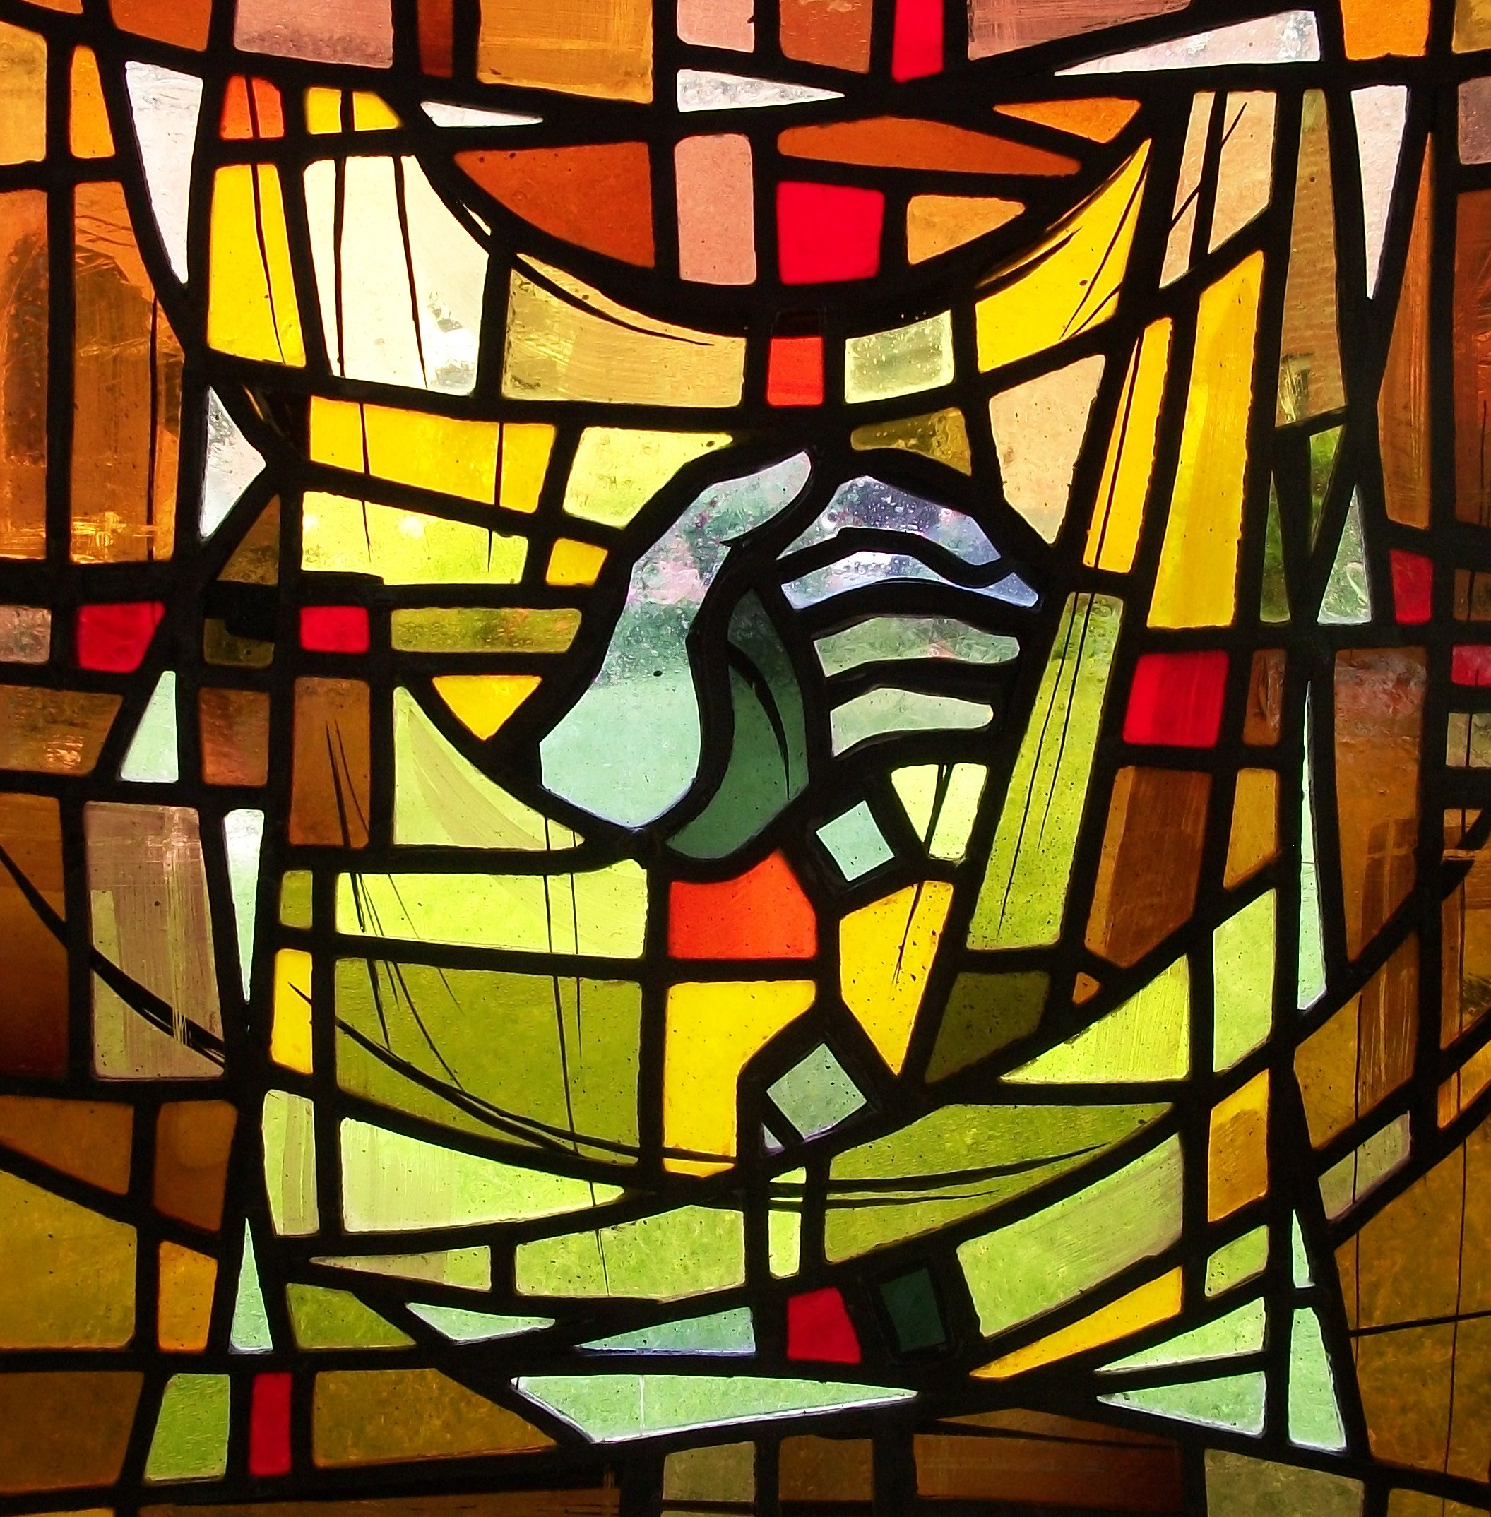
Br. Mark W. Stamm, OSL
Director of the Project and Historian for the Order
April 23, 2023

Novitiate Team Report

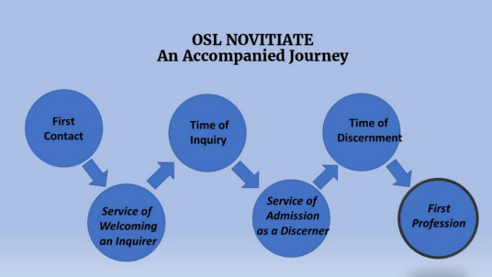
The Novitiate Team consists of myself, Br. Jim DuFriend, Companion for Seekers, Inquirers, and Discerners; and Sr. Barbara Lee, whose wise counsel is most helpful.

The big news here is that by the time of the Spring Council Meeting we will have initiated our first Inquirers Cohort Group. There will be five sessions on ZOOM. Twenty Inquirers and their companions were invited with a Doodle poll to help set the date when most could come. The session will be recorded for those who cannot attend. I will host one session through the summer.

My discernment, with the support of Abbot Elizabeth, is that we need to implement a simpler model of the Cohort Group vision, get started, learn as we go, and give Inquirers the opportunity to feel supported and informed around their questions and concerns. This effort is ancillary to what chapters and companions are doing and does not supplant those continuing relationships.

We remain attentive to what chapters, companions, and Inquirers and Discerners observe about the process. We are now more than four-and-a-half years into this way of welcoming and forming potential members.

Details of the process are available on the Order of Saint Luke Seekers, Inquirers and Discerners in files, “Overview of Inquiry and Final Discernment.” That needs modification considering the Cohort Group component. There is succinct statement on “Memberships” on the order’s website: Memberships (saint-luke.net)

I report the following:

1. Br. Jimmy DuFriend continues to care for, assign companion/mentors, and keep records on inquirers and final discerners. He also maintains and monitors the Facebook group page for Seekers, Inquirers and Final Discerners.

2. Companions: We continue to face a need for members of the Order who are willing and ready to serve as companions to those inquiring about the Order. Resources, both publications and guidelines, are available. I created a new piece, “What Is a Companion? What Can I Expect?” for Inquirers (see pp. 29-31). It is posted on the FB page for seekers, inquirers and discerners. Recruitment and orientation are an ongoing task. I am hopeful that the Cohort Group will make accepting the companion roll seem less daunting.

3. Services for welcoming Inquirers and for admitting Discerners are available on the Facebook Seekers, Inquirers, and Discerners group page. I am ready to assist chapters and associations with planning these services as needed.

If there are new chapters forming, their priors should contact our Provincial General, Sr. Heather or myself for those resources.

Br. Daniel Benedict
April 19, 2023


The Order of Saint Luke
What Is a Companion?
What Does One Do?
An Invitation
A companion is just that! A seasoned member of the Order of Saint Luke who accompanies a seeker inquiring about who we are, what we do, and how we stay in love with God. A companion walks with a person who wants to see if the Order is a good religious vocation fit. Companions are knowledgeable and wise in the ways, stories, and practices of the Order. As the relationship deepens from a time of inquiry to a time of discernment, companions gently guide in testing the discerner’s readiness for profession.

A companion’s work is not to push inquirers through a course of study, but to be a guide for them on a journey of self-discovery in relationship to the Order. Each seeker comes to the Order of Saint Luke as a unique individual with a lifetime of experience, no matter their age. Each inquirer has unique needs, understandings, and sense of direction. Companions have capacity to welcome and to share, to listen and to guide. Welcoming people into the traditions, practices, and communal life of the Order is best accomplished in relational experiences.

We are inviting you to be ready to relate to another who is inquiring and to share your experience, knowledge, and understandings of the Order of Saint Luke with an Inquirer (in the parlance of religious orders, a postulant). In this way, the Inquirer will have someone to talk to, ask questions of, and make discoveries. In time, together you will discern if the Inquirer is ready to become a Discerner (in the parlance of religious orders, a novice).
Expectations:

- Remember that the person you work with and guide is a unique person who is ready to go on a journey with you. If you are part of an active chapter of the Order, then remember that as a member of the chapter you are part of the mentoring team. Engage your chapter in praying for and attending to the Inquirer.

- Pray regularly for the Inquirer assigned to you.

- See that the new Inquirer is welcomed to the Time of Inquiry with a service of “Welcoming an Inquirer”. Br. Jim DuFriend is available to assist you in setting this up.

- Invite the Inquirer to be in contact with you, leaving the responsibility for follow through with them. Encourage them to take the initiative. It is good to agree on a schedule of meeting face to face or via phone or ZOOM or some other digital platform.

- Make participation in a Cohort Group a priority, if your Inquirer elects to participate. During the time of Inquiry, there will be a series of five sessions for a “Cohort Group” made up of Inquirers and their companions led by a member of the Order. The content and experience of the Cohort Group aims at introducing Inquirers to the Order and the Order to the Inquirers. Your presence in the Cohort Group experience is part and parcel to this “introduction.” The group experience will supplement and enhance your companionship.

- Listen deeply and guide the Inquirer as the Spirit prompts you. Lead contemplatively.

- Live the Rule of Life and Service alongside the Inquirer. Share how the Rule of Life and Service shapes your life and invite reflection on how the Rule applies to both your and their daily life.

- Maintain appropriate boundaries. Recognize transference or other warning signs.

- Aim toward mutual discernment of how God is calling the Inquirer in relationship to the Order. If you have concerns or reservations, find ways to explore them. If you need help along the way, ask for it from another member of the Order.

- Send progress reports quarterly to Br. Jim DuFriend, Companion for Inquirers and Discerners (CID) br.jimosl@gmail.com. Indicate completion of Cohort Group participation. Indicate when you started the relationship, its completion, and any other developments or concerns.

- If there is a mutual discernment that the Inquirer desires to enter the Time of Final Discernment, arrange for a service of “Admission to Final Discernment.”

- Communicate your discernment of the Inquirer’s readiness to conclude the Time of Inquiry and what their sense of calling is: either to become a Final Discerner or *find another path for continuing pilgrimage and formation.

- When the Time of Final Discernment comes, communicate to the CID the Discerner’s decision. If it is “I am ready to make my profession” then communicate that both to the CID and to the Chancellor General.

* Part of the Time of Inquiry could include exploration of other religious communities as alternative possibilities. For example, if an Inquirer’s temperament is oriented to apostolic service and social justice, relating to a third order Franciscan community might be worth exploring. Success in the Time of Inquiry and the Time of Final Discernment is not gaining a member of the Order; it is enabling a true discernment of one’s vocation.

Minutes of the Wednesday, October 5, 2022
General Chapter Meeting
Franciscan Renewal Center, Scottsdale, AZ

October 5 2022 11 a.m. at Franciscan Renewal Center, Scottsdale, AZ

Present: Sr. Heather Josselyn-Cranson, Sr. Abbot Elizabeth Moore, Br. George Crisp, Br. Gil Stones, Br. Christopher Montgomery, Sr. Beryl Moore, Br. Jim DuFriend, Sr. Diana DuFriend, Sr. Annie McGregor Meek and Leah Meek, Sr. Elinor Bayse, Sr. Dianne Tobey Covault, Sr. Celia Halfacre, Br. Robert-George Schall, Sr. Kimberly Greway, Br. Derek Kubilus, Br,. French Ball, Sharon Britz, Rob Hermann, Sr. Hilde (Cherlyn) Gates, Sr. Laura King, Sr. Magdalene Ruth (Cynthia) Astle, Abby Peper, Sr. Debbie Neill, Br. John Melick, Sr. Barbara Troxell, Br. Lee Cunningham, Br. Scot Bontrager, Br. Brendan (Dwight) Vogel, Sr. Barbara Blackmon-Fortune, Br. Bil Blackmon-Fortune.

Reports

Abbot Elizabeth
Since we last met, I have spent much time giving thanks that we have been able to hold ourselves together through these emotionally exhausting days. Our hope, even when it seems fragile, is held together by prayer, whether in person or by Zoom or just by the knowledge that our siblings, wherever they are, are also praying. A kind word or a reassuring thought shared on Facebook has lifted my spirits, and I am sure that is true for our siblings as well.

I am grateful to those of you who have accepted the call to service to lead us in worship on feast days throughout the year. Our times of gathering via Zoom deepen our common liturgical practice and are especially helpful for those who cannot participate in local chapters.
We will soon be announcing a new book from OSL Publications written by our own Br. Brendan (aka Br. Dwight) entitled In the Valley of the Shadow. I commend it to you.

Prior General
Br. George announced our return to St. Paul of the Cross in Pittsburgh, PA, for both the Spring Council meeting and the 2023 Retreat. Our Retreat speaker will be Debie Thomas.

Chancellor General (Reported in brief by Br. George)
Approved $500 for Chaplain General of Online Worship, St. Isadore

Provincial General – Pray for the prayer requests listed on the [printed] report. Sr. Heather happy to help new chapters form. Correction: Dayspring Chapter meets every Tuesday night and Thursday morning.

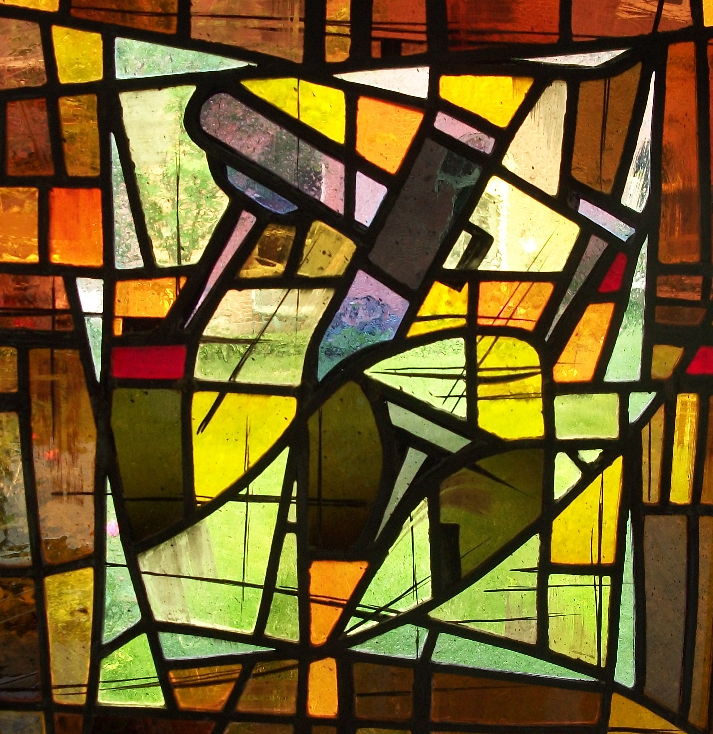
Periodicals – Need a paid staff person for Doxology - deferred until Spring Council meeting when Br. Jonathan can be part of the discussion

The Font – Pay-as-you-go Mail Chimp to reduce costs for distribution was approved.

Life Vows – Sr. Debbie Neill gave her Life Vows testimony.

Chaplain General – Thanks to Sr. Celia Halfacre for accepting this position and to Sr. Kimberly Greway for accepting the office of Chaplain General for Digital Worship.

Director of Acquisitions and Author Relations for OSL Publications
“Living the Rule” will not be sold as a book but will be a downloadable PDF from the website. Br. Mark Stamm is working on John Wesley’s Prayerbook. NAAL - we will not be selling books in person at the 2023 meeting due to its location in Canada. Sr. Heather asked that we have a “discount code” or other means to advertise to NAAL attendees. Request for co-director approved.

Daily Office Revision Team – Lukan Daily Lectionary is coming out soon.

Seekers, Inquirers and Discerners – More inquirers!

Historian/Our Story Project
Abbot plans to appoint some positions of folks who are working hard on this.

Other Business
Abbot Elizabeth noted limited attendance at General Council Meetings and Retreats are likely caused by conflict with academic calendars. Retreat needs to be on/near St. Luke’s Feast Day in October. Should we reschedule Council? Factors which influence a change in location: accommodations, proximity to airport, rooms with private bathrooms, celebration at altar, meeting space.

The minutes in the Book of Reports were approved as submitted.
Sr. Mary Balinda (Dianne) Tobey Covault, Recorder

Brett Isernhagen, Cherlyn (Hildi) Gates, Daniel Benedict, Mary O Benedict, Diane Hayes, and Gregory Hayes.
Sr. Lynn Basan, Br. Paul C. Bilaoen, Br. Dennis Colorado, Br. Manuel B. Estioko, Br. Nixon B. Estioko, Br. Rixon M. Garong, Br. Jonathan Marcos, Br. Pablito Melchor, Sr. Rowena Mina, Br. Allen Munda, Br. Jonathan Razon, Br. Brylex Sosa, Br. Melvin Sulit, and Br. Norlie Vilog.
Debbie Neill, Peter Jamieson, Jeanette Block, Jay Brown, Ceann Hingston, Sandi Hingston, Dan Kaufman, Dee Kaufman, Ginnie Keiser, Fran Noll, Lin Smallwood, Ken Smith, Joyce Trainor, and Charles Wolfram.
Srs. Debbie Neill, Barbara Blackmon Fortune, Becky Walker, Barbara Lee, Corinne Piper, Candace Hallett, and Brs. Matthias Tanner, Bob Schall, Neil Gastonguay, and inquirer Jay Saldana. 32 people receive the e-mail notices.
Br. Andrew Owen, Br. Taylor Nauta, Br. David Collette.
Br. G. Alan Brown, II, Sr. Anna Crocker, Sr. Elise Eslinger, Br. Richard Eslinger, Br. Neil Gaiser, Sr. Barbara Lee, Sr. Alice Kay Lovelace, Br. David Lovelace, Br. Shawn Morris, Br. Kevin Orr, Sr. Corinne Piper, Br. Matthew Van Winkle, and Sr. Becky Walker.
Brett Johnson, Charles Smith, Kimberly Smith, Carl Chamberlain, Steph Brown, Patricia Burgess, Lawrence Lundgren, Jim Knapp, Rachel Stuart, Marilyn Kasperek, and Elisabeth Kisslestein
Sisters Beth Fender, Jennifer Woodruff-Tait, Kathy McCafferty-Rudolph, Melanie Hoth, and Brothers Brian Caughlan, Caleb McGregor, Roger Boyd, Jerry King, Dennis Tuchalski, John Taliwaga, Stephen Wilson, Maurice Midgley, Enrico Esguerra, Kevin Little & Mick Laflin.
Regular attendees: Br. David Eich., Br. Howard Cherry, Sr. Nancy Cartwright, Br. Blaine Wenger, Sr. Kimberly Greway, Br. Guy Camp, Sr. Sarah Elewononi, Br. John Taliwaga, Sr. Carol Gathagan, Sr. Elinor Bayse, Br. David King; Less Regular: Br. Theodore Somes, Br. Rich Canull, Sr. Victoria Rebeck, Sr. Rebecca Holland, Br. James Caffrey, and Sr. Michelle Bodle
Br. Aiden, Br. Jim DuFriend, Sr. Abbot Elizabeth , Sr. Lorenda Hoover, Sr. Dianne McCleary, Sr. Becky Walker, Br. Steve West, Br. Michael Collis, Br. Chris Skillen, Sr. Gail Joyner, Sr. Celia Halfacre, and Br. Wayne Perry.
Mark Stamm, Heather Gottas, Joshua Allison, Annie Meeks, Dianne McCleary, Sally Hoover, and Deborah Wade. (Also others not officially members yet.)

